Issue list

|  |  |  |  |
| --- | --- | --- | --- |
| Issue ID | 001 | **Impact** | Medium |
| Summary | Can not save selected avatar after activation | | |
| Function Area | User profile update | | |
| Reproduce steps | 1. Register a new user and activate 2. After activation, you are brought to the avatar page, select one click submit. | | |
| Expected | I should be able to save. | | |
| Actual | I got phone number exists prompt. | | |
|  | Not sure if the put method cause the issue.  Request Response：  {  "msg": "phone number exists",  "code": 10040,  "data": {},  "success": false,  "version": "2.23.8"  } | | |

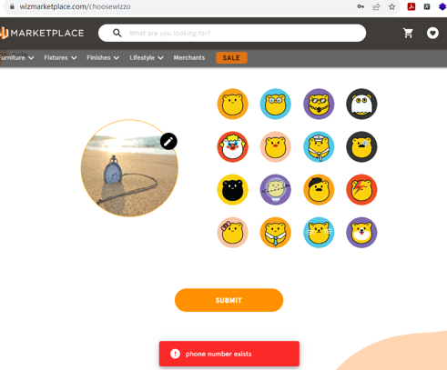

|  |  |  |  |
| --- | --- | --- | --- |
| Issue ID | 002 | **Impact** | High |
| Summary | Login user password is in plain text | | |
| Function Area | Login | | |
| Reproduce steps | 1. Login in 2. Check http request | | |
| Expected | At least password should be encrypted | | |
| Actual | They all plain text | | |
|  |  | | |

|  |  |  |  |
| --- | --- | --- | --- |
| Issue ID | 003 | **Impact** | High |
| Summary | This isn’t validation on old password when change password | | |
| Function Area | Change password | | |
| Reproduce steps | 1. Login in 2. In profile page, fill in wrong old password, fill password and confirm password form. 3. Click ‘Save Changes’ | | |
| Expected | Should not be able to change password and give an meaningful message. | | |
| Actual | It prompts the password saved successfully. | | |

|  |  |  |  |
| --- | --- | --- | --- |
| Issue ID | 004 | **Impact** | High |
| Summary | Can not update password successfully. | | |
| Function Area | Change password | | |
| Reproduce steps | 1. Login in 2. In profile page , fill in correct old password, fill password and confirm password form. 3. Click ‘Save Changes’   If you provide correct old password, prompt profile updated successfully | | |
| Expected | User should be able to login using new password. | | |
| Actual | If I logout and not able to login with new password. | | |
|  | Provide correct old password, still prompt save success, but not able to login using new pwd. | | |

|  |  |  |  |
| --- | --- | --- | --- |
| Issue ID | 005 | **Impact** | Low |
| Summary | Typo in Forget your password page | | |
| Function Area | Reset password | | |
| Reproduce steps | 1. Click login icon 2. Click Forgot password link | | |
| Expected | Enter the email address associated with your account, and we’ll email you a link to reset your password | | |
| Actual | Enter the email address associated with your account, and we’ll email you a link to **rest** your password | | |
|  |  | | |

|  |  |  |  |
| --- | --- | --- | --- |
| Issue ID | 006 | **Impact** | Low |
| Summary | User friendly issue: better to remember the product and add it to favourites after login | | |
| Function Area | Add to Favourites | | |
| Reproduce steps | 1. Select a product and click the heart icon to add to favourites 2. I am brought to the login page 3. Login successfully | | |
| Expected | I think either could be better:   1. Brought me back to the previous product page, then I can click heart icon again. 2. Add the previous product directly to my favourites. | | |
| Actual | None of the above, I need to select that product again to add to favourites. | | |
|  |  | | |